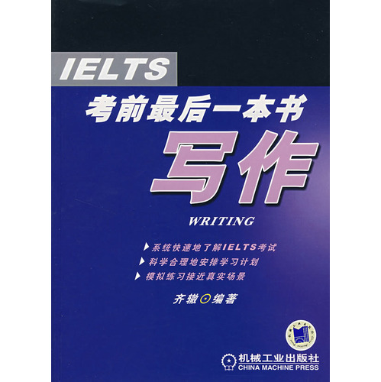
Introduction
Book for IELTS Listening foundation is weak and candidates, to the simple and practical as the main principle, short-term to improve the IELTS listening test scores for the purpose. First of all, from the exam analysis, the idea of ​​the topic and score standards commence to explain, and quickly cut into the candidates pro forma strategy and combat skills. Second, given the core vocabulary, and provides a convenient candidates quickly and easily find the word, reflecting the book as the test characteristics of the last book - simple and practical. Finally, simulation training through three sets of questions enable candidates to consolidate their knowledge.
The book is available for candidates of IELTS exam fast sprint, but also provide a reference for the initial contact with the IELTS candidates.
Directory
Series Preface Preface Chapter 1 IELTS listening exam resolve exam features of the difficulty of the reasons the main test scenario test items and test capability score Frequently Asked Questions Chapter 2 IELTS Listening exam IELTS Listening exam questions, the pro forma Strategy Note Strategy 2006 List of Chapter 3 of the scene instance IELTS listening test combat skills

